DESIGN A SIMPLE TOPOLOGY USING CISCO PACET TRACER

EXPERIMENT NO:5B 231901018

DATE:20/8/2024

AIM:

To Design a simple topology using CiscoPacket Tracer

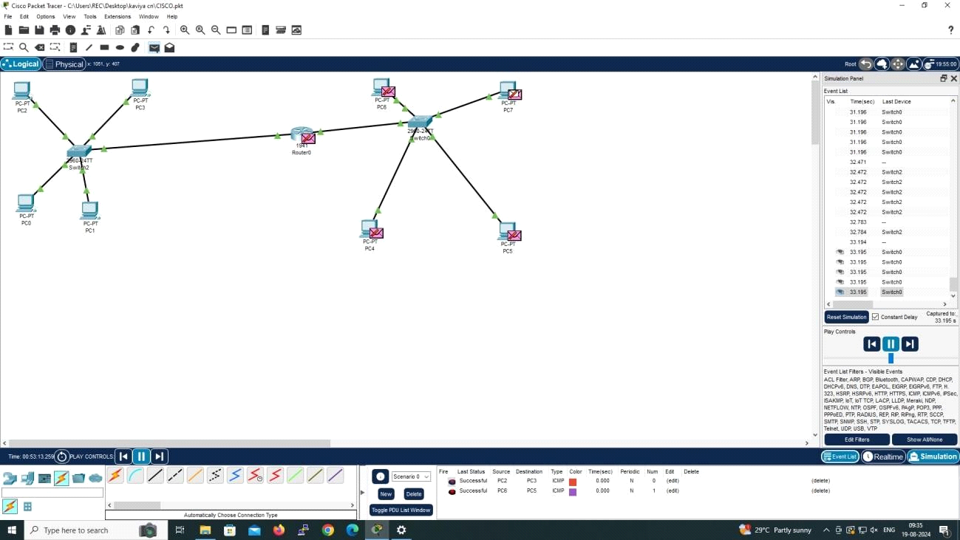

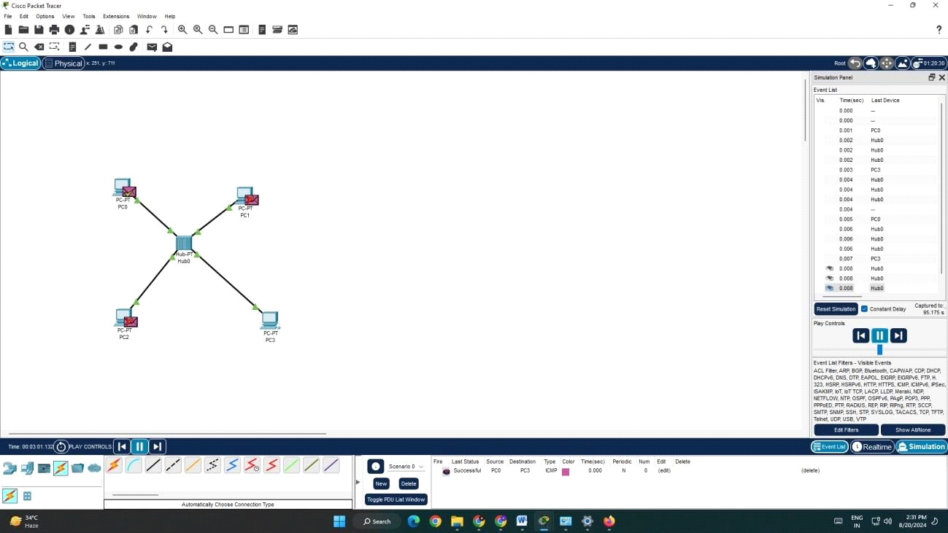

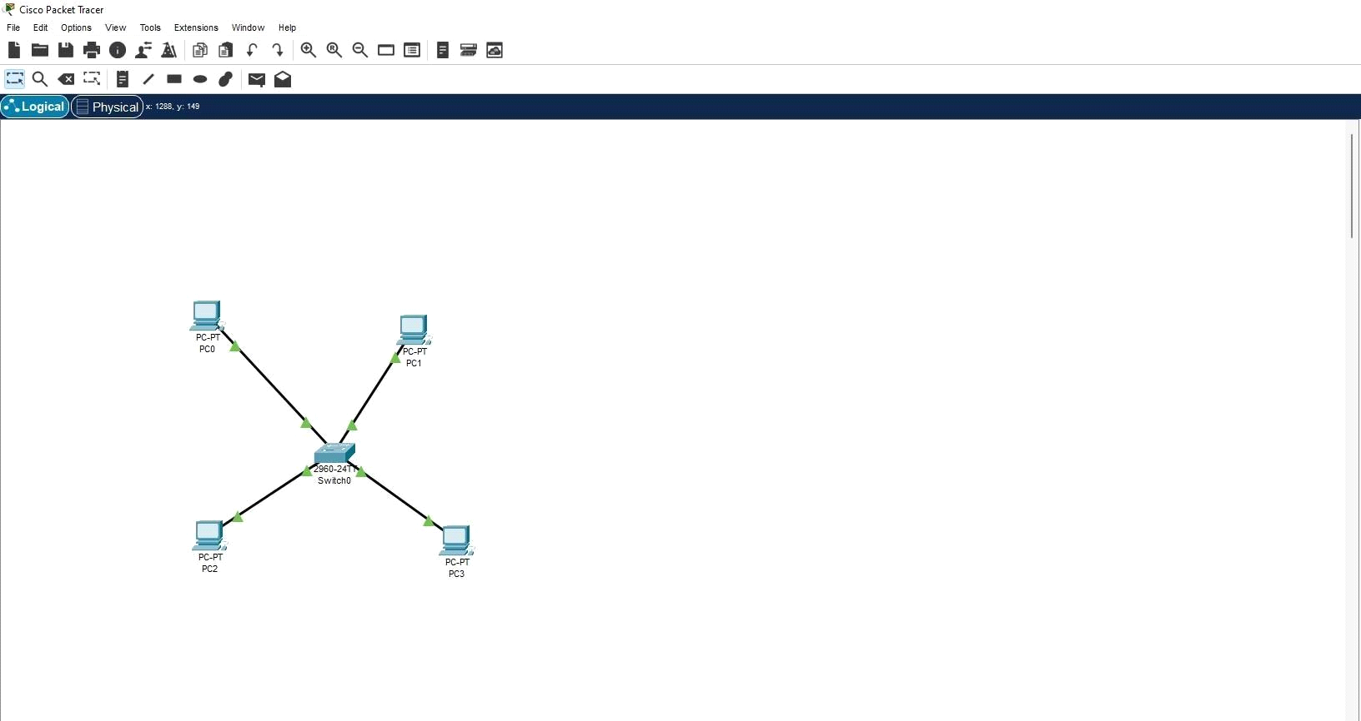

**RESULT:**

A simple topology using CiscoPacket Tracer is Design